4th International Colloquium "Transformer Research and Asset Management”
Pressboard Barriers Versus Full Wrapped Crepe Paper in Exit Insulation System for HV Power Transformers
Selim YUREKTENª, Faruk ERENLER^{b}, Emre ÖZTÜRK^{c}
^{a,b,c}ENPAY Transformer Components, Fakülte Cad No:147/A, 41140 Kocaeli, Turkey
Abstract
It has been experienced by many power engineers that one of the major problems in high voltage (HV) transformers system is breakdown of insulation components. The failures of insulation mostly occur as result of partial discharges (PD). One of the most important and sensitive insulation part of transformer is the insulation between the HV winding and the tank, including the HV bushings. The determination of the quality of transformer insulation, the quality of material to be used and the design play an important role and are decisive about lifetime of power transformers. Due to PD, properties of exit insulation systems deteriorate enormously. In the end, breakdown takes place and entire power system might collapse. Therefore, continuous monitoring and detection of PD is the one of the important task for electrical engineer to keep the high voltage power equipment in healthy condition. When we compare pressboard barrier system with insulation made by full wrapped crepe paper in terms of moisture and ageing; soft crepe paper absorbs more moisture. This absorbed excessive moisture is exposed to a longer drying process. Crepe paper insulation is aged due to this longer process. Particularly problematic is moisture (excessive or ppm) in transformers; it affects both solid and liquid insulation. Most of the water is in the form of dissolved water and is available to move from the oil to the crepe and solid insulation as the transformer progresses towards equilibrium. We aim to examine ageing and moisture effects on the electric breakdown strength of pressboard and crepe paper insulation under AC voltage condition. The barriers have main function to increase the dielectric strength due to divide tighter gaps. So it is possible to optimize of HV transformer lead exit system. Actually barrier system (oil gap) is using also in the windings. A barrier is a structure which is designed to stop electrons that are spreading. In case of non-uniform field oil gaps, the gaps can be divided into narrow ducts. In order to determine these ducts, designers have to use FEM programs and special design curves. This paper will focus on the points of electrostatic stress, moisture behavior, partial discharge and ageing.

© 2017 The Authors. Published by Elsevier Ltd.
Peer-review under responsibility of the organizing committee of ICTRAM 2017.
Keywords: Moulded Pressboard, Barrier, Exit Insulation System (EIS), Crepe Paper, Moisture, Ageing,

- Introduction
In order to ensure a long life time of a transformer the water content in cellulose must be equal to or lower than 0.5% during manufacturing [25]. Yet, cellulose based insulation materials and components display various behaviours against heat and vacuum due to structural differences and geometrical and thickness differences in the place of use.

The period from afterwards of active part drying till when the transformer is placed in the tank and vacuum impregnated is a very critical process. In the meantime, the active part may be kept in production area for a period reaching to several hours. At the same time, moisture absorbing characteristics of insulation materials may vary according to structural properties of material and usage area.

Probable mistakes that can be made during the processes as drying, idle position, vacuum impregnation, conditioning and testing may lead to decades of shortening the lifetime of a transformer which is expected to have a service time more than 50 years under proper conditions.

For this purpose, paper and board, two main materials conditioned equally were compared in terms of drying behaviour, influence on transformer oil, moisture absorption/loss via some basic test methods.[1][2][3]
- Experimental Design and Procedures
Models of insulation structures were examined using two types of materials commonly used in exit insulation system: Crepe paper and moulded pressboard. Examination started with firstly forming two models equivalent to each other in terms of “electrostatic field intensity” via FEM software. The systems were equalized by using same safety coefficient for different levels of voltage. A comparative study is conducted for the simulation of the systems used in lead connection.

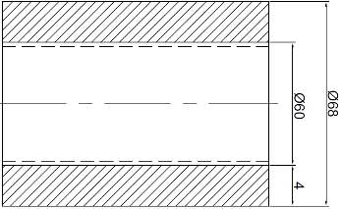
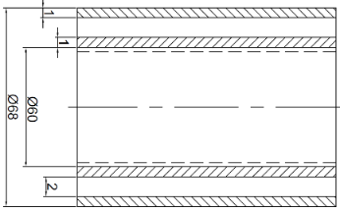

Model A – Crepe Paper (CP) Model B – Moulded Pressboard (MPB)

Model A, 1 mm and 4 mm of crepe paper (CP) insulation on aluminium tube, 50% overlapping (IEC 60554-3-3)
Model B, 1 mm moulded pressboard (MPB) and also 1 mm moulded pressboard barrier (IEC 60641-3-1)
Below studies were conducted on equal models of insulation structures in terms of electrostatic field intensity

  - Electrical Experiments
Electrical Strength and Partial Discharge Inception Voltage (PDIV)

  - Chemical Experiments
  - Observing Amounts of Water Content in Two Models (One week, dried at 105°C, <0,01 mbar)
  - Influence on Transformer Oil via Contamination Tests (One week, at 105°C and 1 month, 105°C)
  - Degree of Polymerization (DP)of Initial and After Drying (for 1 week)

  - Electrical Experiments
High electrical field intensity causes Partial discharges and DP value to reduce in time and significant ageing on the insulation materials. This information should be taken into consideration during the design process. The insulation determines the lifespan of material and consequently transformer service life.

Under operating conditions, long term applications of operating voltage in combination with other factors (temperature, mechanical stress, ionization radiation etc.) reduces the electric strength of insulation material and ultimately takes it out of service due to aging. [4]

The insulation in transformers can be classified as major and minor insulation. The major insulation involves insulation between the windings, the windings and the core, high voltage LEADS and ground while minor insulation is the insulation within the windings, for instance: interturn and interdisc insulation. [5] A decreased electric field intensity at the initial stage of design is aimed for HV and UHV systems. The influence of the geometries is huge in terms of arranging and smoothing the electric field which can be reduced to expected levels by adjusting geometries and distances.

A reduced maximum dielectric stress is usually not enough for a good dielectric perfomance., Volt – time characteristic and partial discharge inception level of insulation material, waveform of the voltage applied, electrode shape and surface conditions, impurities, moisture etc. should also be taken into consideration. [5]

Decreasing regional high stress location and bigger overlaps for better creepage strength, production without voids, uniform electrical fields are some of basic points of insulation design. [6] Positioning of insulation in known geometries will help in better optimization and design of safer systems. Optimized designs can be adapted during the design stage by considering the operating and production conditions of the insulation materials (pre-conditioning, processes, drying, oil absorption etc.).

Two different models of insulation structures are compared in point of strength of oil ducts in below simulation by calculating the electric field between a spherical electrode and a cylindrical electrode details of which are given above. The two models of insulation structures examined are moulded pressboard barrier system and thick insulation made of crepe paper.

Comparison curves and results;
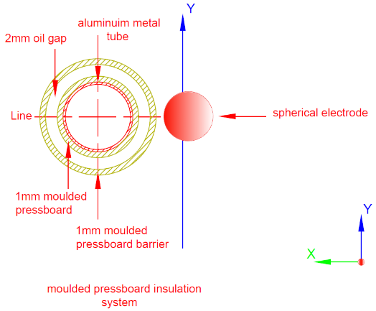
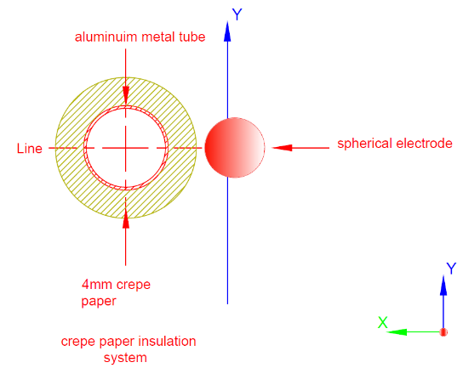

Figure 1 - Model A - Geometry of Crepe Paper Insulation (Wrapped) Figure 2 - Model B - Geometry of Moulded Pressboard Barrier

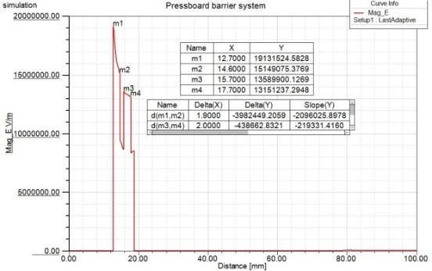

Figure 3. Model A - Electrostatic Field Distribution between Moulded Pressboard Barriers

Figure 4. Electrostatic Field Distribution Between HV and Barrier Figure 5. Electrostatic Field Distribution Between Barrier and Ground

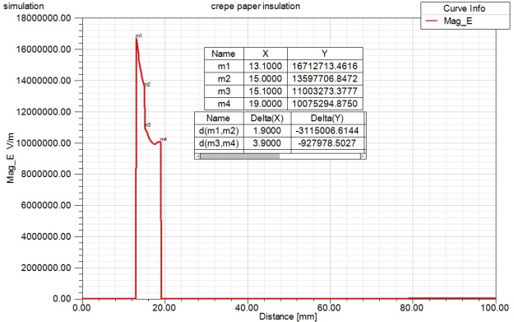
Figure 6. Model B - Electrostatic Field Distribution Figure 7. Model B - Electrostatic Field Distribution Between HV on Crepe Paper sys. (Wrapped) and Crepe Paper

Systems were equalized by keeping the same safety factor in electric fields studies at similar voltage levels.
The studies are made with the curves of partial discharge inception voltage versus width of oil duct for degassed oil. [7]
The oil duct electrical strength for thick crepe paper and thin moulded pressboards barriers are similar according to simulation above. But simulations calculate geometries for optimum conditions. For a more inference the results of the tests conducted are shown below:

Figure 8 – Electrical Strength of 1 mm Insulation Figure 9 – PDIV of 1 mm Insulation

1 mm crepe paper insulation wrapped on aluminium tube, 50% overlapping (IEC 60554-3-3)
1 mm Moulded Pressboard (MPB) on aluminium tube (IEC 60641-3-1)
Below studies were conducted on equal models of insulation structures in terms of electrostatic field intensity

Comparison of the models made of 1 mm crepe paper insulation and 1 mm Mouldable Pressboard from the point of Electrical Strength and Partial Discharge Inception Voltages are given above. Partial Discharge Inception Voltages seem similar as per trend lines. Nevertheless Mouldable Pressboard produces better results compared to crepe paper in terms of Electrical Strength. [8]

Figure 10 - Breakdown Voltage of Insulation Systems (Model A and B) Figure 11 - PDIV of Insulation Systems (Model A and B)

Although crepe paper system is the same as the barrier system with Moulded Pressboard in regards to oil duct strength in the simulation results, the barrier system with Moulded Pressboard is stable when the test results are compared.

  - Chemical Experiments

- Observing Amounts of Water Content in Two Models (Crepe Paper and Mouldable PB)
(1week, 168 h, under 0,01 mbar, at 105°C)

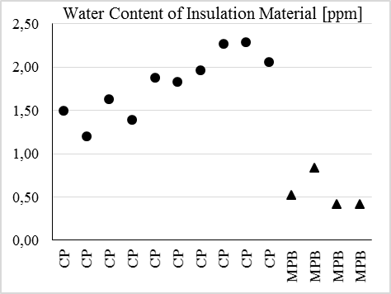Water content tests were conducted on two models dried for 1 week at 105°C under 0,01 mbar in same furnace.
Moulded pressboard (MPB) reached to required values but it was concluded that the water content of crepe paper was not at acceptable level. A water content 1-2 % was measured on crepe paper.

Due to thickness of the crepe paper, the drying is not practicable. The water content remained has a significant effect on ageing of material. [9][10][11]

Figure 12 – Water Content of Insulation Material

The main factors in the aging of insulating winding paper and pressboard in a transformers are the presence of oxygen, temperature and humidity.[12][13][14][15]

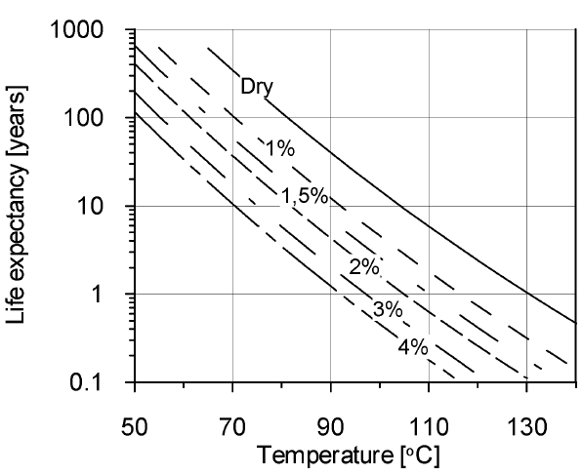
Figure 13. Expected life for solid insulation and its dependence upon moisture and temperature

Ageing of cellulosic insulation in transformers is caused by oxidation, carboxylic acids, and water, which enhance the catalytic efficiency of the acids by promoting their dissociation. [16][17][18][19]

- Influence on Transformer Oil via Contamination Tests
(1 week, at 105°C and 1 month, at 105°C)
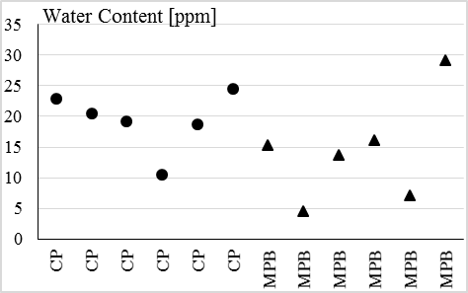
In order to observe moisture absorption, MPB and CP were conditioned at 23°C, 30% RH for 1 hour, 5 hours and 25 hours and then immersed into transformer oil at 105°C for 1 month. The goal here was examining the influence of MBP and CP water absorption rates to transformer oil. When the water content is measured at the end of 1 month, it was ended up discovering that the sample produced with CP caused increment of water content of transformer oil. [20]

Figure 14 – Water Content of Oil

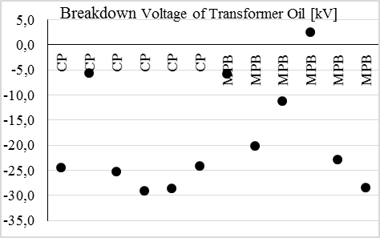
It was expected the first influenced property would be the breakdown voltage (BDV) and it ended up as expected. As seen on the graph, the breakdown voltage value of the transformer oil decreases dramatically. Main point of study here is the excessive reduction of breakdown voltage for the transformer oil in which CP sample was immersed. [20]

Figure 15 – Breakdown Voltage of Oil

- Degree of Polymerization (DP)of Initial and After Drying (for 1 week)

Initial DP values and DP values after 1 week of conditioning at 105°C was measured.
When the results are compared the heat endurance of these two samples are given in the figure 14 and 15.

Figure 16 – DP Value of Initial of Insulation Figure 17 – DP Values of Insulation after Drying
Figure 18 illustrates the influence of operating temperature on moisture and degree of polymerisation of a winding model at the end of 1200 days thermal aging period at 125 °C. Since moisture absorption capacity is directly proportional with temperature, the distribution of the moisture content is reciprocal compared to temperature. The conductor insulation is moister than the barrier in this example however it is usually the opposite. Thermal energy has the main impact on degradation of paper, the degree of polymerisation is lowest on top of the winding where the temperature reaches its highest value. [21][22][23][24]

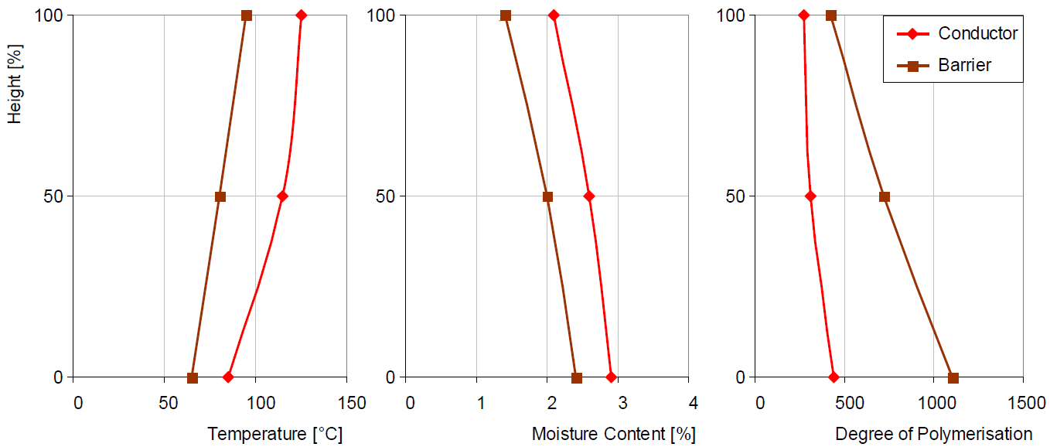
Figure 18: Distribution of Temperature, Moisture and Degree of Polymerisation in the Conductor and Barrier Insulation of a Winding Model

Conclusion:
This experiment researches on two insulation technics, moulded pressboard and crepe paper insulation, through comparison of degree of polymerisation (DP), oil contamination and water content values that are followed by PD inception voltage, breakdown voltage tests on equivalent electrode system which is commonly used in exit insulation systems.

Thin oil ducts make the system more stable as well as increasing the efficiency of the pre-conditioning process compared to thick crepe paper. Drying and oil impregnation processes are easier on Moulded Pressboard barriers thanks to thin layers. The differences obtained as a result of this comparison will be bigger at rates of 420-550 kV and 800 kV. When thick wrapped crepe paper insulation is used for exit insulation system at 420-550 kV, 24-36 mm thickness crepe paper must be wrapped on a conductive metal tube. An equivalent system is formed by using 5 mm basic insulation on conductive tube and 3 pieces of 3 mm thickness Moulded Pressboard barriers.

Thanks to oil ducts, the heat spreads homogeneously in exit insulation systems produced with Moulded Pressboard barriers. A massive structure occurs in the systems made of crepe paper. Therefore, distribution of heat in barrier systems is more effective. Ageing dependent on temperature is decelerated thanks to the fact that barrier systems allows the heat distribution.

Vaporization of the water in barrier systems with Moulded Pressboard is easier as well as the absorption of water is harder. Longer durations and higher temperatures of drying is needed for crepe paper systems due to the fact that the water content must be lower than %0.5. This causes the DP value of the material to decrease in no time. Decrease in DP value means the shortening of transformer life.
References
[1] S.Yurekten, E.Öztürk, F.Erenler, Insulation components for HV Power Transformers, Travek X-th International Scentific and Technical Conference,Power and Distributive Transformers,Reactors,Systems of Diagnostics, 21-22 June 2011
[2] F.Erenler, S.Yurekten, The Quality Aspects of Solid Insulation in Power Transformers and Reactors, In association with CIGRE, 5.International Conference on Large Power Transformers-Modern Trends in Application, Installation, Operation & Maintenance, New Delhi, 22-25 Jan.2013
[3] S.Yurekten,E.Öztürk,F.Erenler, Modern Trends in Application of Insulation Systems for Power Transformers, 11.International Conference Trafosem 2011, Indian Transformer Manufacturers Association,NewDelhi 21-22 Nov. 2011
[4] Vasily Y. Ushakov, Insulation of High-Voltage Equipment, Fırst Edition, Springer-Verlag Berlin Heidelberg, 2004
[5] S.V.Kulkarni, S.A. Khaparde, Transformer Engineering: Design, Technology, and Diagnostics, Second Edition, CRC press.
[6] S.Yurekten, Technical Assesment of Lead Exit and Design Process, Travek VII International Scientific and Technical Conference, Large Power Transformers and Diagnostic Systems, Moscow 22-23 June 2010
[7] E.Öztürk , Exit Insulation Systems (EIS)&Middle Exit Systems, 12.International Conference on Transformer Trafosem 2013, Innovative Quest for transformer Technology for Efficient and reliable Power, Bengaluru 15.nov.2013
[8] H.-Z. Ding, Z. D. Wang, P. Jarman, Ageing and Moisture Effects on the AC Electrical Strength of Transformerboard, 2007 International Conference on Solid Dielectrics, Winchester, UK, July 8-13, 2007
[9] Pankaj Shukla, Y.R. Sood, R.K. Jarial, Experimental Evaluation of Water Content In Transformer Oil, International Journal of Innovative
Research in Science, Engineering and Technology, Vol. 2, Issue 1, Janauary 2013
[10] Andras Csernatony-Hoffer, Experimental Results with Vacuum Drying of Thick Soft Paper Insulation, IEEE Transactions on Electrical
Insulation, Vol. EI-3, No. 4, November 1968
[11] Brian Sparling, Jacques Aubin, Assessing Water Content in Insulating Paper of Power Transformers
[12] Lars E. Lundgaard, Walter Hansen, Dag Linhjell, Terence J. Painter, Ageing of Oil-Impregnated Paper in Power Transformers, IEEE Transactions on power Delivery, Vol.19, No.1, January 2004
[13] Loai S. Nasrat, Nesrine Kassem, Nadia Shukry, Aging Effect on Characteristics of Oil Impregnated Insulation Paper for Power Transformers 21.10.2012
[14] Lars E Lundgaard, Dave Allan, Ivanka Atanasova-Höhlein, Regine Clavreul, Mats O.Dahlund, Hans Peter Gasser, Richard Heywood, Christoph Krause, Marie-Claude Lessard, Tapan Kumar Saha, Victor Sokolov, Alfonso de Pablo, CIGRE WG D1.53, Ageing of Impregnated Cellulose for Transformers
[15] H.P. Gasser, J. Huser, C. Krause, V. Dahinden, A.M. Emsley, Determining The Ageing Parameters of Cellulosic Insulation in A Transformer
[16] J. Gielniak, A. Graczkowski, S. Gubanski, H. Moranda, H. Moscicka-Grzesiak, K. Walczak, Influence of Thermal Ageing on Dielectric Response of Oil-Paper Insulation, Materials Science-Poland, Vol. 27, No. 4/2, 2009
[17] Mohamad Ghaffarian Niasar, Mechanisms of Electrical Ageing of Oilimpregnated, Paper Due to Partial Discharge, Doctoral Thesis in Electrical Systems, KTH Electrical Engineering, Stockholm, Sweden, 2015
[18] J. Dai, Z. D. Wang, P. Jarman, 13 - Moisture and Aging Effect on the Creepage Discharge Characteristics at the Oil/Transformerboard Interface under Divergent Field, 2008 Annual Report Conference on Electrical Insulation Dielectric Phenomena
[19] Laurentiu Badicu, Petru V. Notingher, Laurentiu Dumitran, Gabriel TANASESCU, Dorin Popa, and Gheorghe Batır, Thermal Ageing of Oil Impregnated Paper for Power Transformers Insulation Systems, Annals of the University of Craiova, Electrical Engineering series, No. 34, 2010; ISN1842-4805
[20] F.Erenler, G.Newesely, S.Yurekten , Compatibility Test of Pressboard with Transformer Oil , CIGRE International Colloquium Transformer Research and Asset Management,Dubrovnik,16-18 may 2012
[21] CIGRE Working Group A2.30 – (349) Moisture Equilibrium and Moisture Migration within Transformer Insulation Systems.
[22] Ch. Krause, H.P. Gasser, K. Kiriyanthan, The Remaining Water In Power Transformer Insulation After Drying, Proceedings of the 16th International Symposium on High Voltage Engineering Copyright °c 2009 SAIEE, Innes House, Johannesburg
[23] Youyuan Wang, Kun Xiao, Bijun Chen Yuanlong Li, Study of the Impact of Initial Moisture Content in Oil Impregnated Insulation Paper on Thermal Aging Rate of Condenser Bushing, Energies 2015, 8.
[24] Andreas Küchler, Hochspannungs-technik, Springer, VDI, 2009
[25] CIGRE Brochure 349, WG A2.30, Moisture Equilibrium and Moisture Migration Within Transformer Insulation Systems, June 2008

