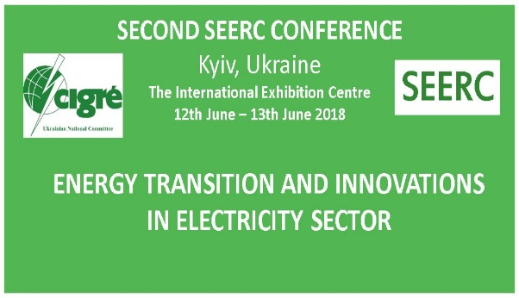
SECOND EUROPEAN CIGRE
REGIONAL CONFERENCE 2018
12-13 June 2018
Kyiv – Ukraine
Organization: CIGRE Ukraine

CALL FOR PAPERS
Second European CIGRE Regional Conference – South East European Region of CIGRE (SEERC) ENERGY TRANSITION AND INNOVATIONS IN ELECTRICITY SECTOR

Deadline for receipt of abstracts: December 15, 2017

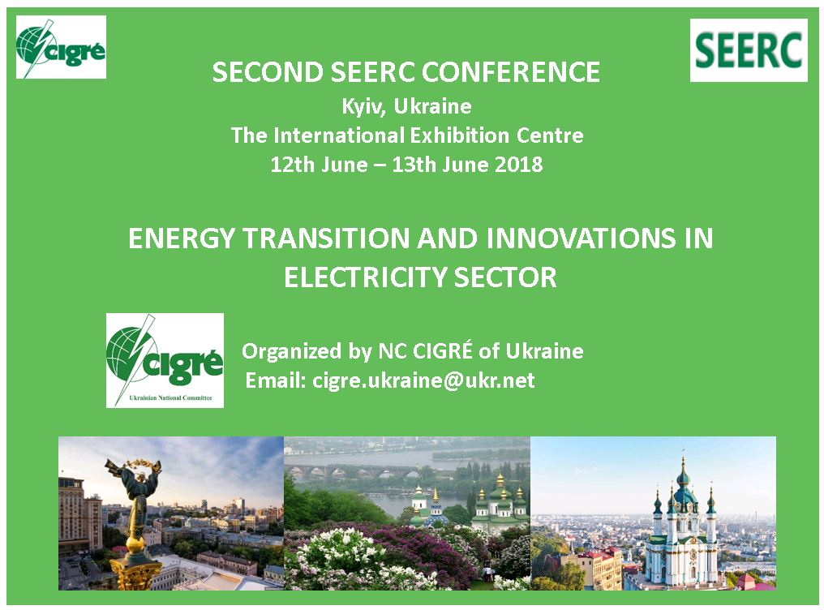
The CIGRÉ Ukrainian National Committee is delighted to host the Second SEERC Conference and invites you to submit synopsizes and to participate at conference. Subtitle of the conference will be Energy Transition and Innovations in Electricity Sector with focus on the ENERGY INFRASTRUCTURE in the Central and South East Europe.
Conference is supported by SEERC member states: Austria, Bosna in Herzegovina, Croatia, Czech Republic & Slovakia, Greece, Hungary, Italy, Macedonia, Montenegro, Romania, Serbia, Slovenia, Turkey, Ukraine and CIGRE Paris Central Office.
Global energy system and particularly electricity sector is in fundamentally changing process, which is change faster than expected. SEERC area is large area with many interesting projects, innovative solutions, and vision of future electric power system. Technical Advisory Committee of SEERC selected three main topics for second conference in Kiev.
Ukrainian NC CIGRE is organizing conference and exhibition, which will take place in The International Exhibition Centre in Kyiv, Ukraine.
The main topics of Second Conference 2018 cover the technical activities of such CIGRE Study Committees: A2, A3, B2, B3, B4, B5, C1, C5, and C6.

Conference Topics:
TOPIC 1: Regional aspects of electricity market development and transition
Vision of future Central and South East European Energy Market, metering issues in the Region, new Trading issues, new interconnections (OHL and cables, submarine cables, DCHV), Demand side involvement in market. This topic will be coordinate with CIGRE Study Committees: B1, B2, C2, C5, and D2;

TOPIC 2: Resilience issues of Electric Power Systems in SEERC region
Examples of the Electricity system outages (Ice storms, Floods and Storm surge, cyber-attacks, major operation errors, physical attacks, wildfires, earthquakes), management of resilience issues taking in account novel grid codes, preparation programs, examples of good practice. This topic will be coordinate with CIGRE Study Committees: B2, B5, C2, C5, and D2;

TOPIC 3: Innovation in electric power infrastructure of the Region
Technical and non-technical innovations in electricity sector in region, Microgrids and Smart Grids projects, Demand side readjustments, penetration of Electrical vehicles, innovations in system operation processes, new business frameworks, intelligent utilities. This topic will be coordinate with CIGRE Study Committees: A2, A3, C1, C6, and D2;

Academic forum: Research and development at universities or presentation of selected dissertation from SEERC countries relating on vision of future Power Systems.
Student’s Forum: Selected presentation of papers (students and young engineers)
Regional Industry Forum:

Organizing Committee:
Chair: Yuriy Bondarenko (CIGRE Ukrainian NC Vice President, Chairmen of SEERC)

Conference Technic and Reviewing Committee:
Chair: Maks Babuder (NC CIGRE Slovenia)
Members: from SEERC countries

Language
The official language of the conference is English.

Key dates:
Deadline for receipt of abstracts (200-300 words): December 15, 2017
Notification of synopsis acceptance: January 31, 2018
Deadline for full papers submission: March 31, 2018
More information
Please visit our website for more information http://cigre.org.ua (site will be available from August 2017)
E-Mail: seerc.conference2018@gmail.com

