4th International Colloquium "Transformer Research and Asset Management”

The Parameters of Generated Sound Level of Transformer Cores

Selim Yürektena, Yunus Sertb, Miroslav Trnanc, Enis Ceyland

a,b,dEnpay , Fakülte Cad No:147/A,41140 Kocaeli, Turkey

cEnpay,, Krskany 38, 934 01, Levice Slovak Republic

Abstract

Low level of the audible sound is a compulsory aspect for transformers today. Therefore it is important to determine the parameters of generated sound in transformer. The sources of sound in transformer are; Load sound in the windings, auxiliary equipment sound and mainly core sound (no load sound).The paper will focus on the core sound.

Core sound generated by magnetostrictive vibration of core steel laminations and magneto-motive Maxwell forces. It is extremely sensitive to applied compressive stress. For better understanding of those effects it is necessary to investigate flux distribution in core. One of the main sources of sound in the core is magnetostriction in laminations.

This study performed to reduce the generated sound at the source. In order to have correct result the tests made in a special sensitive noise lab according to rules mentioned in IEC 60076-10. In 3 cases, study illustrate the parameters of core sound levels.

1. Effects of stacking performance of magnetic steel (limbs, yokes, corners, T-joints) presented in a case study in detail. How big the difference is shown in the measurement results in table and curves.
2. Some quality difference of magnetic steel from different supplier shows the measurement curves.
3. The clamping arrangement influences strong the structural dynamic behavior of the core. The vibration behavior of core structure has a big effect to sound generation. For mitigation of core sound provide various actions. A case study shows the results.

In the paper various test procedures with different core size are described and results with curves are presented. The Prediction of transformer core sound can be clarified with these tests. In order to mitigate the sound level in cores this test results can give some support. IEC 60076-10 Power transformers Part 10: Determination of sound levels has detail information for test environment and procedure.

© 2017 The Authors. Published by Elsevier Ltd.

Peer-review under responsibility of the organizing committee of ICTRAM 2017.

**1. INTRODUCTION**

Power transformers are significant sound sources. Therefore it is very important to optimize the acoustic behavior of them in order to minimize the level of sound. In the last decade transformer core sound levels are considerably lower than those built 30-40 years ago. A number of studies about this phenomenon were made [1, 2, 3, 4, 5, 6]. Magnetostriction is significant source of no-load sound. In recent times power loss and magnetostriction of grain-oriented electrical steel have been considerably reduced [7]. By applying high quality of silicon steels like HIB or laser treated material it is still possible to reduce the sound level of core fore 4-5 dB .This paper studies on the sources of core sound and their possible mitigations. Simple way to reduce sound is the reduction in core flux density, but this method has negative effect on the cost and size of transformer [2], [15]. Reduced core flux density increases load losses. The designer has to find the optimal value of induction for best solution. The basic sources and their mathematical explanations are given in the next paragraph. There are three case studies which show different results. The sound level measurements of the cores are made in a precision laboratory, which specification is given in detail.

**2. THE BASIC SOURCES OF CORE SOUND**

The basic sources from Transformer Core Sound (no load sound) - Core vibration are:

1. Magnetostrictive forces
2. Magnetomotive (magnetic) forces
3. Mechanical forces on the core

Magnetostrictive force causes a vibration of the entire core with twice of the line frequency. Due to magnetostriction, vibrations are the major contributors of core sound. Magnetomotive force causes the laminations of the core to strike against each other if there are residual gaps between them [7], [13].

The magnetomotive force per unit cross-sectional area can be estimated by [2]

(1+cos2ωt) *(1)*

where **()** is peak value of the flux density in gap, **(µ0)** is permeability of free space, **(ω)** is fundamental angular frequency.

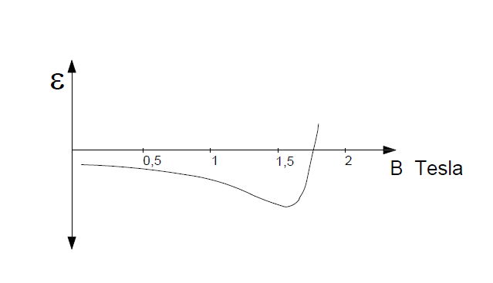The magnetic forces are mostly in the non-magnetic gaps (air-gaps) at the joints between limbs and yokes .Magnetic and magnetostrictive forces vibrate the core. Principally the step-lap stacking reduces noise levels compared with the conventional lap joints [3, 4]. Also increasing the number of laminations per layer raises the sound level. The gaps not only affect core losses but also core sound level.

The magnetostriction phenomenon is described by coefficient of (ε) [2]

**ε =** *(2)*

Where **(** is the length of the lamination sheet and **(Δ)** denotes its change.

Fig.1 magnetostriction curve

Figure 1 shows magnetostriction curve [2].

All ferromagnetic materials have this phenomenon which attributed to rotations of small magnetic domains in the materials. The orientation of domains by the imposition of the magnetic field creates a strain field [17], [18], [20].

The magnetostriction forces are much higher than magnetic forces. [3, 4, 5]

The magnetostriction of grain oriented silicon steel is extremely sensitive to applied compressive stress.

Core lamination steel has different elasticity properties in rolling and cross rolling directions [7, 8, 9]

Mechanical Forces on the core are occurred mainly from clamping arrangement, which is essential to hold together the laminations. They influence the dynamic behavior of the core. But clamping torque on the clamping irons affects the magnetostriction on the laminations. Accurate mechanical design of them can help to reduce of the core sound level [6]. A bonding of laminations also reduces the core sound [9, 10].

To predict core sound level, a FEM was developed by using COMSOL Multiphyiscs AC/DC and acoustic modules

[14, 16].Basic equations to start with FEM-COMSOL modules are Maxwell equations of the magnetic cores, these are:

**B=µH** *(3)*

Where (**B** flux density), **(µ)** is the magnetic permeability in the core, **(H)** the magnetic field strength

**I = σ E** *(4)*

Where **(I)** is the current density, **(σ)** conductivity, **(E)** is the electric field density.

**3. OVERVIEW OF SOUND MEASUREMENT CONDITIONS**

The measurement of no-load noise of core has been performed indoor conditions and below specified laboratory. The data’s given below are “Corrected Sound Pressure Level (LpA)” described in IEC60076-10 & 11.2

**Sound test room inner dimensions:** 8m x 6m x 4,5m

**Position of the microphones:**

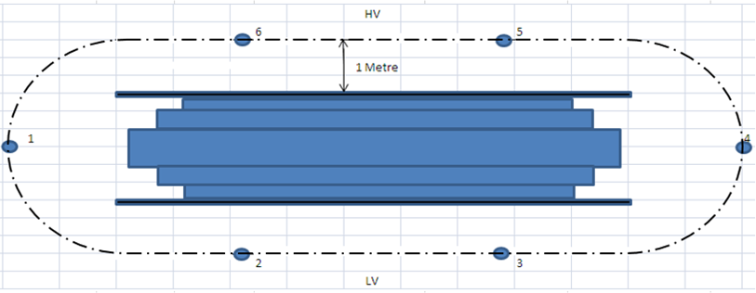

Fig.2 Microphones detail

Specially isolated metal door to reduce reflection values of test room

background noise: approx. below 20 dBA

theoretical range of measurement: 23-130 dBA SPL

**Measuring devices:**

NTI Audio XL2 – sound level meter and acoustic analyser

calibrator device - Bruel and Kjaer

equipped with 12 pcs measuring microphones

measurement made according to IEC 60076-10

measurement method - sound pressure level ( dBA)

**4. CASE STUDYS**

1. **Case Study:**

Effect of stacking performance of magnetic steel (limbs, yokes, T-joints) [3],[4]

Some of reasons of generated sound level in core are construction, clamps, tightening forces and material as described in introduction of this paper. As we know the cores with step-lap joints have less core sound level then the cores with conventional lap joints. During production of identical cores it was detected that identical cores have different results due to workmanship quality, even same material is used, and tightened with same forces. [11, 12, 13]

The study here in this clause have been made to observe the effect of workmanship quality to sound level of core. Two identical core have been produced for this purpose. The first core was precisely stacked with 0-0,1mm drift between sheets in same step and the second core was non-precisely stacked with 0, 5-1 mm drift between sheets in same step [14, 15, 16]. The 3D illustration of core is below in fig.3 and the “drift” mentioned in previous sentences are also illustrated in fig. 4. (a) and (b).

The core produced for this experiment is 840kg.

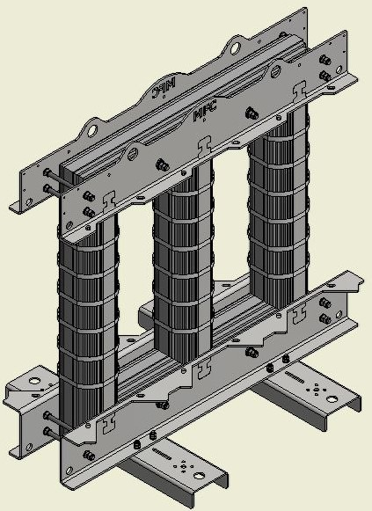

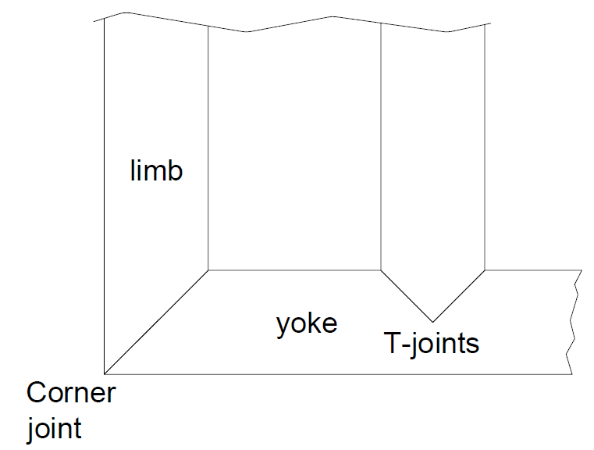

Fig. 4. (a)

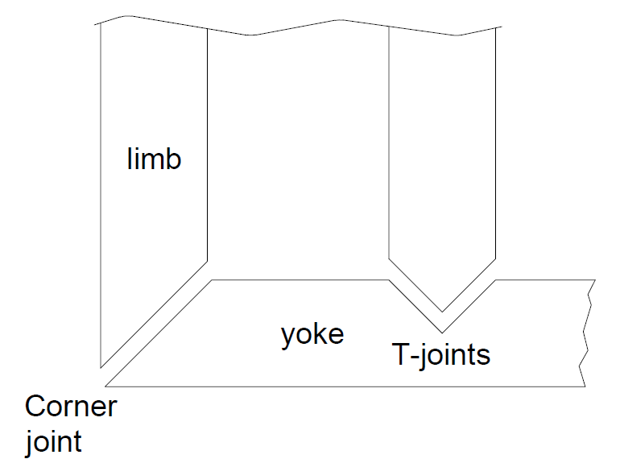

Fig. 4. (b)

Fig. 3

**Results;**

The gaps (drift) at joints affect the core sound level as well as no-load losses. This study has been performed due to different results of identical cores and it was resulted that stacking quality of core has a huge effect on no-load noise performance of cores. 3 main inductions have been examined and the no-load sound of cores has been measured, the results of non-precisely stacked cores were 1, 7 times, 1, 64 times and 1, 38 times higher than precisely stacked cores at 1,3T, 1,5T and 1,7T respectively.

The detailed results and obtained sound levels were given in table.1 and Graph.1. Due to below results, it can be concluded that stacking performance of bare cores have a considerable effect on core no-load results.

Table 1. Sound Measured Results [dB]

|  |  |  |
| --- | --- | --- |
| Induction (T) | precisely stacked | non-precisely stacked |
| 1,3 | 33,1 | 56,3 |
| 1,5 | 37,9 | 62,3 |
| 1,7 | 45,6 | 63,3 |

Graph. 1

1. **Case Study**

Some quality difference of magnetic steel from different supplier.

Due to different production methods, different magnetostriction and vibration values of different sources, we would like to see and evaluate different sources’ performance for no-load sound values.

For this purpose, 2 identical cores were produced with 2 different source’s material and coded “material-A and B”. The no-load sound level of cores were measured and compared in table-2 and graph-2 below.

The core produced for this experiment is 2000 kg

Table 2. Sound Measured Results [dB]

|  |  |  |
| --- | --- | --- |
| Induction (T) | Material A | Material B |
| 1,3 | 35,4 | 34,6 |
| 1,5 | 40,7 | 42,4 |
| 1,7 | 48,3 | 51,9 |

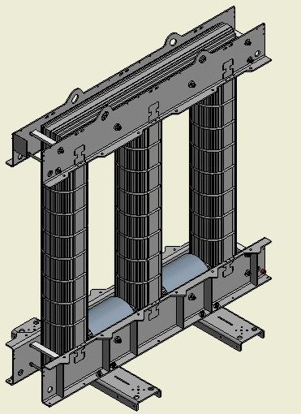

Graph. 2

Fig. 5

**Results;**

As similar to no-load loss behavior of cores, the identical cores might generate different no-load sound due to different sources. Same grade electrical steel of two different sources was examined for this study and it was observed that the sound level was varied between 3%-7%.

The obtained results and related curves are shown in table.2 and graph.2 above. 2-3 dB differences have been measured at induction more then 1,4T and the sound levels of different sources are almost equal below 1,4T

1. **Case Study:**

The clamping arrangement have strongly influences on the structural dynamic behavior of the core

One of the contributor of generated sound in core is clamps. The vibration starts in core and it starts to vibrate the clamps and clamps create additional sound in whole unit. To avoid the vibration transfer from core through the clamps, soft or anti-vibrations materials may be used between electromagnetic steel and clamps in core design. [17, 18, 19]

To see the effect of insulation material between electromagnetic steel and clamps, same core has been experimented with different insulation materials. There are many possibilities but we have tried 3 materials only. Those are IEC60893-3-2 Type EP GC 203 (will be abbreviated as HGW), IEC 60341-3-1 Type 3.1 A (will be abbreviated as PSP) and Nitril-Butadien-Rubber (will be abbreviated as NBR).

The core produced for this experiment is 2000kg.

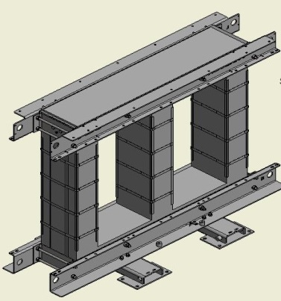

To measure the hardness of above material was not possible so the densities of all were measured to compare and identify some of parameters of materials.

The densities are given below.

HGW 2mm thickness ; 1,85g/cm3

PSP 2 mm thickness ; 1,20g/cm3

NBR 2 mm thickness ; 1,43g/cm3

Fig.6

**Results;**

The main reason of sound generated in core is vibration which starts in the electrical steel and affects the metal clamps, metal clamps vibrate and this additional vibration on metal clamps cause additional sound in core. One of important precaution to reduce sound level of core is to avoid the vibration on metal clamps caused by electrical steel. For this purpose, three material were examined and it was resulted that as long as material used between electrical steel and metal clamps to isolate both of them gets softer, the no-load sound of cores are reduced.

The obtained results and related curves are shown in table.3 and graph.3 below.

Graph. 3

Table 3. Sound Measured Results [dB]

|  |  |  |  |
| --- | --- | --- | --- |
| Inductance (T) | PSP | HGW | NBR |
| 1,3 | 49,1 | 51,2 | 48,4 |
| 1,5 | 56,4 | 58,0 | 51,9 |
| 1,7 | 59,5 | 61,4 | 55,7 |

1. **CONCLUSION**

It is clear that the magnetostriction is a main cause of transformer core vibration and noise.

y

It has been studied on the core sound and vibration specifics. After that the details of this phenomenon were given [15, 16, 17, 18]

The specific information about test room and the measuring devices has been given.

Magnetostrictive forces, magnetomotive forces and mechanical forces on the core are studied in detail. [20]

In 3 Case studies, the different relations with core sound levels are shown:

**1.** The stacking quality of core has a huge effect on no-load sound level performance of core. The detailed results were given in table.

**2.** Same grade electrical steel of two different sources was experimented. Difference was varied between 3%-7%.

**3.** To reduce the sound level of the core, 3 different insulation material placed between core and clamps and core no-load sound measured, materials reduced sound levels in different ratios.

**6. REFERENCES**

[1] Moses A. J. Measurement of magnetostriction and vibration with regard to transformer noise. IEEE Trans Magn 1974; 10(2):154-156.

[2] Kulkarni S.V. Khaparde S. A. Transformer Engineering. Design, Technology and Diagnostic, second edition 2012, CRC Press Taylor &Francis Group

[3] Mizokami M. Yabumoto M. Kurosaki Y. Vibration analysis of a 3-Phase model Transformer Core, Electrical Engineering in Japan, vol .119, pp.1-8, 1997

[4] Mizokami M. Kurosaki Y. Variation of Noise and Magnetostriction Associated with Joint Types of

Transformer Core, Electrical Engineering in Japan, Vol 194, No.2, 2016

[5] Valkovic Z. Investigations of core noise levels using a dry-type transformer model, Journal of Magnetism and magnetic Materials, vol.160, pp.205-206, 1996

[6] Valkovic Z. Effects of Transformer Core design on Noise Level, J. Phys. IV France vol. 08Pr2-603-pr2 606, 1998

[7] Shilyashki G. Pfützner H. Anger J. Gramm K. Hofbauer F. Galabov V. Mulasalihovic E. Magnetostriction of Transformer Core Steel Considering Rotational Magnetization, Manucr. for IEEE Trans. on Magnetics, 2.revision

[8] Shilyashki G. Pfützner H. Hofbauer F. Sabic D. Galabov V. Magnetostriction Distribution in a Model Transformer Core

[9] Tabrizi S. Study of effective Method of characterization of Magnetostriction and its fundamental Effects on Transformer Core Noise, PHD Thesis (subm.) ,Cardiff Univ.2013

[10] Phophongviwat T. Investigation of the Influence of Magnetostriction and Magnetic Forces on Transformer Core Noise and Vibration , PHD Thesis (subm.) , Cardiff Univ.2013

[11] Masti R.S. Desmet W. Heylen W. On the Influence of Core Laminations upon Power Transformer Noise, PROCEEDINGS OF ISMA 2004

[12] Zhu L. Zhang X. Yang Q. Zhang X. Design and Analyze the Optimum Operating Point between Magnetic Flux Density and Vibration Noise of transformer Cores , The open Electrical & Electronic Engineering Journal , 2014,8,552-558

[13] Phoshoko M. Power Transformer Noise: Sources, Factors and remedies, Transmission and distribution, energize-August 2013-Page 3

[14] Hattel R. Kavasoglu M. Daneryd A. Ploetner C. Prediction of Transformer Core Noise, Expert from Proceedings of the 2014 COMSOL Conference in Cambridge

[15] Negi R. Singh P. Shah G.K. Causes of Noise Generation & its Mitigation in Transformer, International Journal of Advanced in Electrical, Electronics and Instrumentation Engineering Vol.2, Issue 5, May 2013

[16] Kreutzer M. Modelling of Core Noise from Power Transformers, Master of Science Thesis 2011, KTH Vetenskap Och Konst

[17] Ghalamestani S.G. Vandevelde L. Melkebeek J. Identification of Transformer Core Vibrations and the Effect of Third Harmonic in the Electricity Grid , International Journal of Electrical, Computer, Energetic, Electronic and Communication Engineering Vol.8,No:6,2014

[18] Stirl T, Harthun J, Hofmann F. New trends in noise reduction of power transformers. CIRED 21st International Conference on Electricity Distribution, Frankfurt, 6-9 June 2011

[19] Lukic L. Djapic M. Lukic D. Petrovic A. Aspects of design of power Transformers for noise reduction, 23.National & 4. International Conference NOISE AND VIBRATION, Nis 17-19.10. 2012

[20] Lupi N. Magnetostriction vs. Magnetoelastic Effects, European School on Magnetism, Cluj-Napoca, Romania, September 9-18, 2007