The Stray Loss Evaluation and Shielding in Structural Parts of Power Transformers

Selim Yurekten
ENPAY Transformer Components
Turkey

SUMMARY
Power Transformers are the costliest and vital parts of transmission network. Their design is a complex task. During recent decades, the development of design has been an extension of the use of computers and numerical tools. The magnetic shielding calculation and design of power transformers are one of important issues, especially with the growth of transformer ratings. The load losses are subdivided in to I²R losses and stray losses. The stray load losses in power transformers are mainly in copper parts (windings, leads and connecting conductors) roughly 50 %, and the other half in structural parts (tanks, yoke clamping structures), and in the core, flitch plates, core edges (outside packages of the core). Stray flux departing radially from outer windings, gives rise to eddy current losses in the tank and in the yoke clamping plates. Accurate stray loss calculations are also required to meet guaranteed losses and to determine possible hot-spots in structural components. Due to increasing energy costs, minimization of the losses is an important aspect. All these additional losses can’t be separately measured. Even, during reliable operation of the transformer, the allowable heating is caused by stray losses. However, the figures in the next pages, shows the stray loss hot- spot distributions, which cause overheating. If stray losses are concentrated in small areas without properly cooled, local overheating can arise, causing transformer operating failure. In addition to this, if the flux density becomes too high, excessive temperature rise can result problem.
This paper focusses on the stray losses “eddy current losses, according to Faraday Law and Lenz Law” in structural parts and in the core, and discusses recent trends in design of the magnetic shunts in power transformers. There are various methods, designs and materials for reduction of these losses, which we will study in the following sections. In practice the magnetic shunts with silicon steel strips on the tank walls are more effective in controlling stray losses as compared to the nonmagnetic shields like aluminium or copper shields.
Effects of various manufacturing processes are also highlighted in the paper.
KEYWORDS
Power transformer, eddy current, stray loss, hot spot, magnetic shielding, FEM, structural parts.

s.yurekten@enpay.com

Introduction
The matter of the leakage flux becomes increasingly important with growing of the power rating of transformers. Stray losses are one of the components of load losses [1]. High current and high circuit impedance in transformer are also very crucial. In case of stray loss concentration in small areas that are not properly cooled, local overheating can arise, causing transformer operation failure. In order to determine local losses and temperatures on that place, thermocouples were installed and measured the result. It is very important and necessary to study accurately the stray losses and magnetic leakage in the power transformer to reduce them to a reasonable level, and to prevent possible local overheating of the structural parts resulting from these losses. The eddy current losses due to leakage magnetic fields occur in the conductive parts, such as tank walls, yoke clamps and other structural parts, which are made of generally low carbon steel and have large thickness about 7-15mm. Those thicknesses are much larger than the magnetic field penetration depth (skin effect). This kind of steel is magnetic and has high electrical conductivity. On the other side the current passing windings and leads give rise to eddy current losses and consequently local over-heating “hot spot” in metallic parts (IEEE C57.91). By criterion of the capitalized expenses the shielding is beneficial. Because the manufacturing and installation cost of shunts packets are greatly lower than capitalized load losses cost. Loss capitalization is an important factor in transformer owning cost. Therefore, to reduction of stray losses give the advantage for the lower owning cost. The eddy current losses generally can be written as:
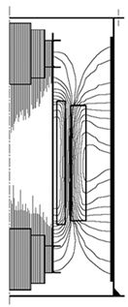
P = k B² f² t²
Where,
K = constant depends on the size and inversely proportional to material resistivity
B = peak value of the magnetic induction
f = frequency of the excitation source
t = material thickness
The eddy current loss increases with increasing frequency and with increasing conductivity.
In order to calculate the stray losses on all parts of the transformer, best way to use is FEM finite element method [2] [3]. FEM is a numerical technique to solve the differential and integral equations such as electromagnetic, thermal conductivity etc.

Fig 1 Stray field in transformer

A major portion of these stray losses occurs in tank and core clamping parts, but also in smaller amount in flitch plates of core limbs Fig.1, edge stacks and high current bushing mounting plates. All in those parts created hot spots must be eliminate. Particularly the high current bushing mounting plates is generating very hot spots. We will study the solving of these problems in the following files.
1-Tank walls
2-Yoke clamping structures
3-Flitch plates (tie bars), core edge stacks, and bus-bars/bushings mounting plates
The simulation of the electro- magnetic field on these parts can be realized in different ways. The basic knowledge of the topic is given in many publications [4] [5].
1-Tank walls
Almost half of the total stray losses in structural parts and core occur in the tank walls. The material of the tank is from mild steel with nonlinear permeability. The shunts material are from CRGO steel with linear permeability. Transformer designers determine one of the cost-effective measures to minimize the losses [6]. Magnetic shunts are using to attract and re- directs the stray flux through theirs low loss route. However there are several methods for calculating of this kind of losses. One of them is the analytical method and the other is FEM computer simulation, 2-D and 3-D, which is a sophisticated tool used widely to solve generally engineering problems [7]. Due to using of 2D-3D FEM it is possible to determine stray losses for transformers with greater accuracy. This simulations based to Maxwell equations [8] [9], Figure 2.
As example, with analytical method calculated benefit of the shunts in some power transformers are:
Transformer data tank loss without shunt (kW) tank loss with shunt (kW) advantage (kW)
500 MVA/400 kV, 60 Hz. 3/0 138, 48 61, 11 77, 37
400 MVA/500 kV, 50 Hz. 3/2 36, 21 24, 55 11, 66
125 MVA/230 kV, 50 Hz. 3/2 19, 11 8, 83 10, 28
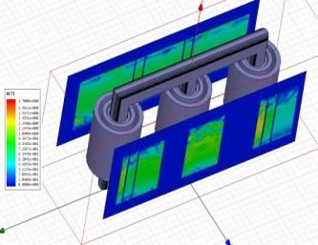
In the Fig 2 the simulation presented the vertical types of magnetic shunts on the wall. 3-D FEM methods are more accurate compare with other calculation methods for estimation of the stray losses in tank. This allows a better optimization of the shunts and it can be studied number of shunts, thicknesses etc. for all service conditions like over voltages, overloads.

In practice there are two types of magnetic shunt elements mostly used. In fig3 illustrated wide-band types. The wide- band shunt is placed parallel on the Tank Wall. Eddy currents wide-band shunt induces more stray losses, compare to edge- wise shunt [10].
Fig 2 Simulation model of transformer, for the tank walls
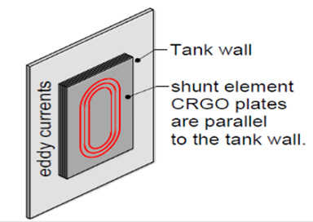

The other type of shunt is narrow ribbon shunt. The ribbons are placed perpendicular to the wall so the flux is occurrence the thickness of ribbon resulting in negligible eddy loss. This type in Fig 4 is preferred to us.
Thickness of shunt elements depends on amount of flux collected. Gap placed on tank between 2 shunts elements wall should be as minimum as mechanically possible. The shunts should cover at least 70% of area in front of windings. The elements must be without any gap.
On the other hand, the leads with high current can cause severe problems in transformer with high loss densities in metal parts [11] [12]. Special care should be taken also on the overlapping areas of the leads of the windings [13] [14].

Fig 3 width-band shunt
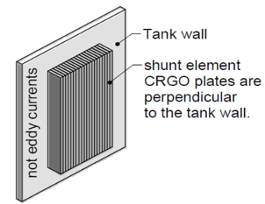

Fig 4 Narrow ribbon edge-wise shunt

The shielding made from copper and aluminium is not used in practise because they are so complicated and costly. In the tank walls are another critical areas, one is above tank shields and the other one next to high current leads, which has to be carefully studied [15] [16].
2. Yoke clamping structures
Generally the clamping structures are provided to prevent any movement of the windings due to the forces which are produced during short circuits. These parts consist of yoke clamp, yoke shield, clamping ring, flitch plates and frames, Figure 10. Yoke clamping structures (yoke beams/ frames) are made of mild steel and used for clamping of yokes and supporting the windings. The frames are in the stray magnetic field of the windings and the stray flux can produce considerable eddy current losses in them. Stray losses in power transformers occur mostly after tank walls in yoke clamping structure [17]. Loss calculations from radial flux hitting these kinds of parts are principally similar to loss calculation in conductors. There are 2-D FEM available for this kind of calculation. But using 3D model as for other eddy losses it can be the result more accurately. This simulation for calculating yoke clamp temperature has been verified by the installation of thermocouples on the core clamps and comparing the result. The Area of them very critical and need to more attention, very high loss possible [18] [19].
Stray losses (hot spots) of the yoke clamping plates are reduced by using horizontal yoke shunts, which are positioned just below the yoke plates. The yoke clamps have a large horizontal surface area and close to the windings and their leakage flux, Fig 5 ,[20] [21].The end clamps are in similar shape and used mostly in bottom side from big powers and in autotransformers Fig 6-7. However in case of magnetic shunts used here, it is observed that the flux tends to pass through the shunts [22] [23]. The shunts for that cover only one phase so that the leakage flux must return to the core [24].
Up to mid side of power transformers as yoke clamping plates can be use form densified electrical grade laminated wood. This type of material can reduce the stray losses and subsequent reduction in heating effects.

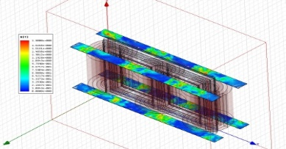
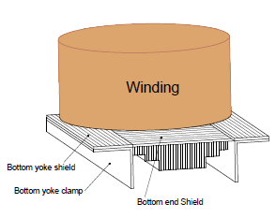
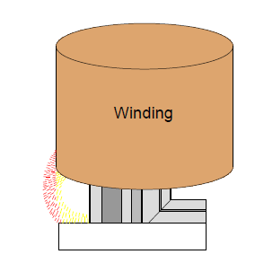

Fig 5 Simulation model of the yoke clamping plates
Fig 6 magnetic field distribution from winding in the bottom side
Fig 7 present the bottom clamp shielding and bottom end shielding

3. Flitch plates (tie bars), core edge stacks, and bus- bars/bushings mounting plates
3. A. Flitch Plates (tie bars)
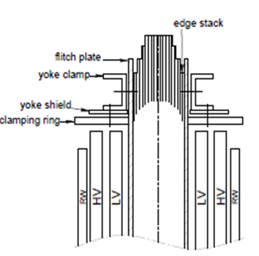
Flitch plates used to hold and compress core and for lifting of them Fig 8. Their stray losses are about (incl. frame losses) 5-8% of the total stray losses in structural parts. In small power transformers, flitch plates from mild steel without any slots can use because not cause hot spots. In larger transformers occurrence field increases and more hot spots, so it is important to reduce the eddy losses in flitch plates, it must be used non- magnetic stainless steel [25]. To reduce the losses have to use proper design, and a combination of shielding. The plates from non- magnetic stainless steel without slots can help up to any limit. In case of higher losses the slotted plates must be use Fig 9. The slots can have limited length or full length in depending of the losses. Of course in manufacturing process it is not simple. 2-D and 3-D FEM analysis can give more detail information and accurate result. In Fig 10 present the flitch plate on the core limb.
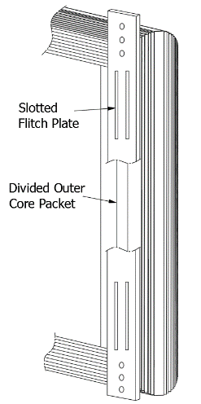
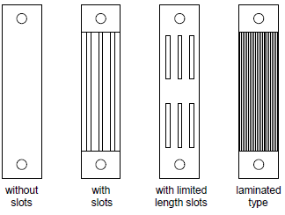

Fig 8 flitch plate, edge stack, yoke shield
Fig 10 slotted flitch plates and core edge stack
Fig 9 Flitch plates types [1]

For the efficiency of the loss reduction to find the right length and number of the slots can be use accurately 3-D field calculation. In many cases the magnitude of flux density is the highest at top and bottom winding edges, this results higher losses and hot spots in the same regions of the flitch plates. In order to avoid such cases, the slots locations are provided at top and bottom of the flitch plates.
There is another complicated but more effective type of flitch plates, laminated type. According simulation of the laminated types the loss is much lower as compared to stainless steel plate. Hence particularly for higher rating power transformers, generator transformers laminated types are much useful. But the manufacturing process is not easy. This type can help also in the problem of the stray loss in core edge stack.
3. B. Core Edge Stack
There is another stray loss in core edge stack, which occur due to flux influence on core laminations. The outside packets of lamination on core limbs are subjected to these condition. Particularly in large transformers is to consider these situation. Stray flux come perpendicular in legs and induces big eddy
Fig 8 Core edge stack
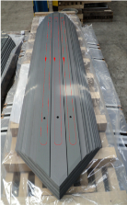
currents, big losses in core parts with large wides. Core edge stack losses can be 8-12 % of the total stray losses, it depends of the core leg with. The flitch plate type (magnetic or non-magnetic) has also an effect on the core edge loss. To evaluate exact of that is a challenge to designer. 3-D FEM can help for a precise result for the solution. The first core step is usually split in to two or three parts (divided outer core packet) to reduce the core edge loss in large power transformers [26]. In the Fig 11 red lines shows the stray flux lines.
Fig 11 Core edge stack

3. C. Bus-Bars / Bushing Mounting Plates
The eddy current losses and consequently local over heating (hot-spot) in cover plates of distribution transformers must be also evaluated [27]. Due to increasing of the rating of transformers the currents of windings increase also, particularly in high current (low voltage) side. High current leads can cause high stray losses and temperature rise Fig 12. When currents in the leads are higher approx. 2500 Amps bus-bars are used. Leads arrangement has also an important influence on the tank losses. Particularly the currents in low voltage side of large generator step-up transformers and tertiary windings of auto transformers can be extremely high. These transformers have mostly low-voltage winding delta-connection, and the leakage magnetic flux around high-current delta connections could cause very high additional losses [28]. If these leakages are not controlled properly it can cause excessive hot spots in the tank around the low voltage side, tertiary bushings and leads. In the design by the layout of the connection of these kind of typical transformers could be controlled the extra stray losses. There are different methods for calculating the losses in bushing mounting plates of transformers, as example analytical formulation, loss estimation from the steady-state temperature rise, loss estimation from the initial temperature rise, 3-D FEM analysis. The last one allows anti magnetic and copper shielding to be optimized, as a more accurate compare to other methods. Especially it is the case on the overlapping areas of the leads. To minimize the field effect in three- phase connection, the leads of all the three- phases can be grouped together. The leads overlapping and their distance to the tank influence very high the loss density, which cause transformer heating. Sometimes even though the magnetic shunts used for reducing losses, but generates hotspots due to its inappropriate arrangement. The FEM model can have on large powers a good solution for that [29]. Generally used bushing mounting plates are either mild steel, or mild steel plates with non-magnetic stainless steel inserts or stainless steel plates, Fig 13. Flange areas must be studied carefully, because they may be poorly cooled and could lead to seal failure [30] [31]. Fig 12 shows the surface loss densities on the plate, the highest losses are near the center hole.
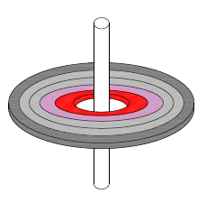
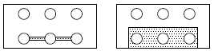

Fig 13 Bushing mounting plates with nonmagnetic inserts in different design
Fig 12 surface loss densities on the bushing holes

Conclusions
For reliable transformers the stray losses must be controlled. To reduction of the stray losses give advantage for the lower owning cost of the transformers. One part of the load losses are the stray losses ‘eddy current loses according to Faraday Law and Lenz Low’, which are generated by stray flux fields both internal and external to the windings. We studied in this paper the stray losses which are in external to the windings. A major portion of stray losses occurs in tank, core clamping parts, smaller amount in flitch plates of core limbs, edge stacks and high current bushing mounting plates. Evaluation and shielding in structural parts of power transformers have been presented. The simulation with 2D and 3D FEM give a result with greater accuracy. The reduction of eddy current losses and the elimination of hot spots all in structural parts are an important consideration in power transformer designs. The designers use various cost- effective measures to minimize this kind of losses. Inside of the tank walls and clamps must have from magnetic core pack shielding. From CRGO magnetic ribbons, the edge-wise shunts are better solution. Flitch plates, end bars must be segmented steel or stainless. High current bus- bars must shield magnetic structures, copper/ aluminium or stainless.

BIBLIOGRAPHY
[1] S.V. Kulkarni, S.A. Khaparde, Transformer Engineering, CRC Press, Taylor& Francis Group, 2013
[2] S.V. Kulkarni, S.A. Khaparde, Stray Loss Evaluation in Power Transformers- A Review Indian Institute of Technology Bombay, December 4, 2008 at 06:16 from IEEE.
[3] B.K.Lal, Amit Kumar, Modern Trend in Control of Leakage Flux in Power transformer, International Conference Power Transformers, 6-7 April 2000, New Delhi.
[4] N. Takahashi, T. Sakura, Z. Cheng, Nonlinear Analysis of Eddy current and Hysteresis Losses of 3-D Stray Field Loss Model (Problem 21), Okoyama University, Year 2000.
[5] O.Biro, G.Koczka, B.Wagner, U.Baumgartner, G.Leber, Finite Element Method for Nonlinear Eddy Current Problems in Power Transformers, CIGRE International colloquium Transformer Research and Asset Management, Dubrovnik, Croatia,May 16-18, 2012.
[6] N.Takahashi, et.al. Optimal design of Tank Shield Model of Transformer, IEEE Transactions on Magnetics,vol.36,no. 4, July 2000, 1089-1093.
[7] Y.Wang, S. Song, J. Chi, Effect of Magnetic Shunts on the Eddy Losses of a transformer Tank, Advanced Materials Research, 2012 Trans Tech Publications, Switzerland.
[8] P.Hamberger, M. Lackner, B. Zheng, Evaluation of Stray Flux and Eddy Current Distribution in Power transformers.
[9] L.Kralj, D.Milijavec, Stray Losses in Power transformer Tank Walls and Construction parts, University of Ljubljana, Faculty of Electrical Engineering, Slovenia.
[10] S.Yurekten, State-of- the Art Tank Shelding (shunts) for HV Power Transformers, Travek 25-26 June 2013,Moscow
[11] Z. Janic, Z. Valkovic, Optimization of Transformer Tank Shields, ISEF 2005- XII International Symposium on Electromagnetic Fields in Mechatronics,Electrical Electronic Engineering, Baiona, Spain September 15-17, 2005.
[12] L. Yan, L. Longnv, J. Yongteng, Z.Bo, 3D Finite Element Analysis of the Stray Loss in Power transformer Structure Parts, Energy and Power Eng., 2013, 5, 1089, 1092,Scentific research.
[13] Y.Sumei, C.Zhiguang, Y. Qingxin, Z. Xiaoquan, The Stray Loss on Magnetic Shielding in Power transformers, WSEAS Int. Conf. on Applied Computer Science, Hangzhou,China, April 15, 2007
[14] L. Strac, Three- Phase Shunts for Stray Magnetic Field, 4th International Colloquium ‘ Transformer Research and asset Management’ Elsevier Sincence Direct 202 (2017),183-188.
[15] M.Moghaddami, A.I. Sarwat, F.De Leon, Reduction of Stray Loss in Power Transformers using Horizontal Magnetic Wall Shunts, IEEE Transactions on Magnetics 2016.
[16] C.Chetan, M.L. Jain, Analysis of Stray Losses in Power Transformers by 3-D Magnetic Field Simulation, Fifteenth National Power Systems Conference (NPSC), IIT Bombay, December 2008
[17] Kishan V Dave, S.M. Kanani, Use of FEM for Reduction of Transformer Stray Loss, International Journal of Science, Engineering and technology Research,Volume 5,Issue 2, February 2016.
[18] J.M.Jadav, A.S.Reddy, Prediction of Hotspot Location in a Power Transformer Considering Stray Losses using FEM, International Journal of Applied Engineering Research ISSN 0973 – 4562 Volume 13, Number 1 (2018).
[19] Y.Higuchi, M.Koisumi, S.Saito, Three Dimensional Eddy Current Calculation with Integral Equation Method for Transformers,IEEE Transactions Magnetichs,vol.33,March1997.
[20] A.M.Patel, A.S. Jhala, H.M. Karkar, analysis of Stray Losses Calculation in Auto-Transformer Using Coupled IEM and FEM Technique, International Journal of Advance Engineering and research Development, Volume 1, Issue 3, April 2014.
[21] S.A.Mousavi, D.Bonmann, G Endgahl, Stray Flux in Power transformers due to DC Magnetizations, CIGRE 3. International Colloquium Research and Asset Management, Split,Croatia, October 15-15, 2014.
[22] S.Dasara,V.P.Mishra, Shielding Measures of power transformer to mitigate Stray loss and hot Spot through coupled 3D FEA, IET Journals, 3rd July 2017.
[23] D.Kerenyi, Stray Load in Yoke – Beams of transformers, A. Savini et al. Electromagnetic Fields in Electrical Engineering,Plenum Press,New York 1988.
[24] Z.Janic, Z. Valkovic, z. Stih, Stray Losses İn Transformer clamping Plate, Electrical Engineering Institute Zagrep, Croatia, June 20, 2006.
[25] Kulkarni, S. V., Koppikar, D. A., Srinivas, P.N., Khaparde, S. A., Jain,R. Evaluation of flitch plate lossesin power transformers, IEEE Transactions on Power Delivery, Vol.14, No. 3, July 1999, pp.996- 1001.
[26] Carpenter, C. J. Sharples, K.O., Djurovich, M. Heating in transformer cores due to radial leakage flux, Part II: computed results, proceedings IEE December 1977.
[27] S.V.Kulkarni, J.C.Olivares, R.Escarela-Perez, V.K.Lakhiani and Turowski, Evaluation of Eddy Current Losses in the Cover Plates of Distribution Transformers, Article 2004, source IEEE Xplore.
[28] S.Selvaraj, G.Calowaerts, R.Mathersa, R.Mertens, M.B.Varrier, Investigation of Impact of Magnetic Shunt Parameters on Temperature Distribution in Transformer Tanks, CIGRE 3. Intern. Colloq. Transformer Research and Asset Management, Split, Croatia, October 15, 2014
[29] Z. Valkovic, Some Aspects of Stray Losses in Large Power Transformers, Institut Koncar, Zagreb, Croatia, S 238-241.
[30] R.M. Del Vecchio, Eddy Current Losses in a Conducting Plate due to a Collection of Bus Bars carrying Current to different Magnitudes and Phases, IEEE trans .Magnetics vol. 39, no. 1,pp. 549-552, 2003.
[31] Z. Janic, I.Sulc, Z. Valkovic, Tank Loss for different Leads Arrangement, CIGRE International
Colloquium Transformer Research and Asset Management, Cavtat, Croatia, November 12- 14, 2009.

